**Lab Exercise 4– Terraform Variables** **Objective:**

Learn how to define and use variables in Terraform configuration.

**Prerequisites:**

• Install Terraform on your machine.

**Steps:**

1. **Create a Terraform Directory:** 
   * Create a new directory for your Terraform project.

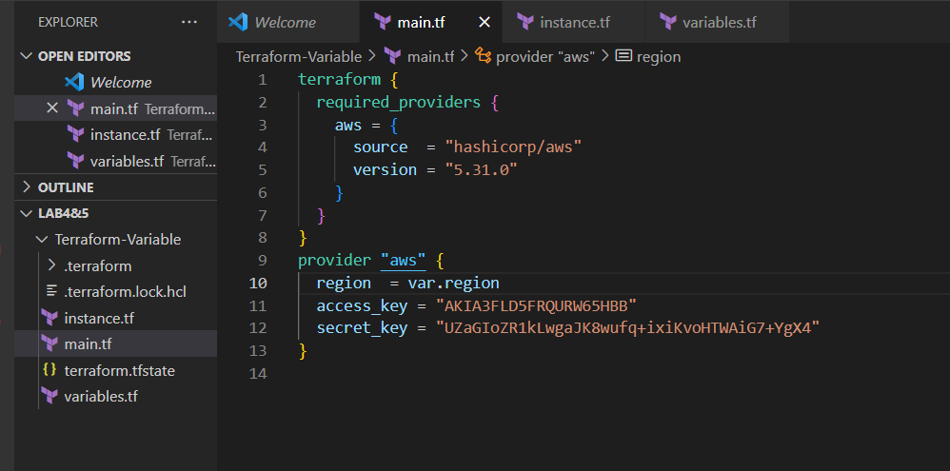

**mkdir terraform-variables cd terraform-variables**

1. **Create a Terraform Configuration File:** 
   * Create a file named main.tf within your project directory.

**# main.tf**

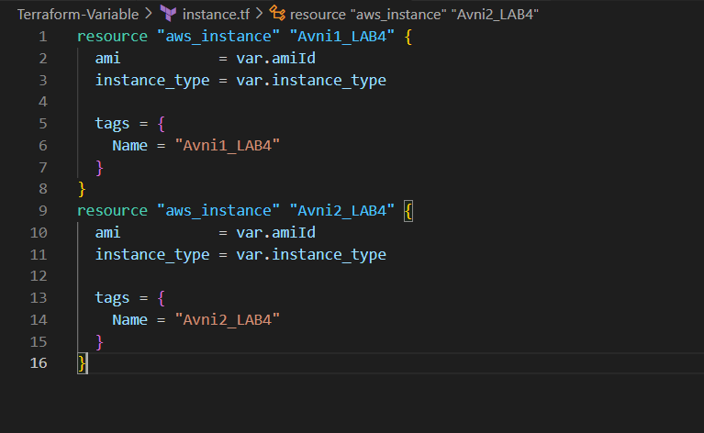

|  |
| --- |
| **provider "aws" { region = "us-west-2"**  **}**  **resource "aws_instance" "example" { ami = "ami-0c55b159cbfafe1f0" instance_type = "t2.micro"**  **}** |

1. **Define Variables:** 
   * Open a new file named variables.tf. Define variables for region, ami, and instance_type.

**# variables.tf**

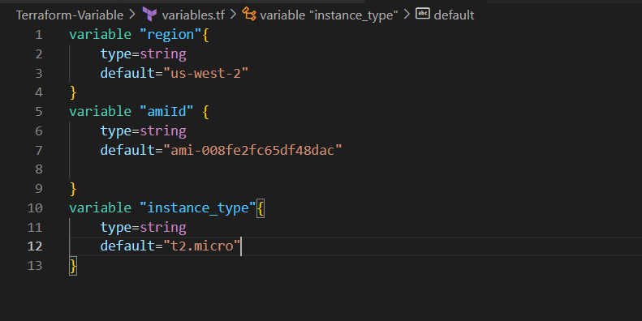

|  |
| --- |
| **variable "region" { description = "AWS region" default = "us-west-2"**  **}**    **variable "ami" { description = "AMI ID"**  **default = "ami-0c55b159cbfafe1f0"**  **}** |

**variable "instance_type" { description = "EC2 Instance Type" default = "t2.micro" }**

**4.Use Variables in main.tf:**

* + Modify main.tf to use the variables. **# main.tf**

**provider "aws" { region = var.region**

**}**

**resource "aws_instance" "example" {**

**ami = var.ami**

**instance_type = var.instance_type**

**}**

1. **Initialize and Apply:** 
   * Run the following Terraform commands to initialize and apply the configuration.

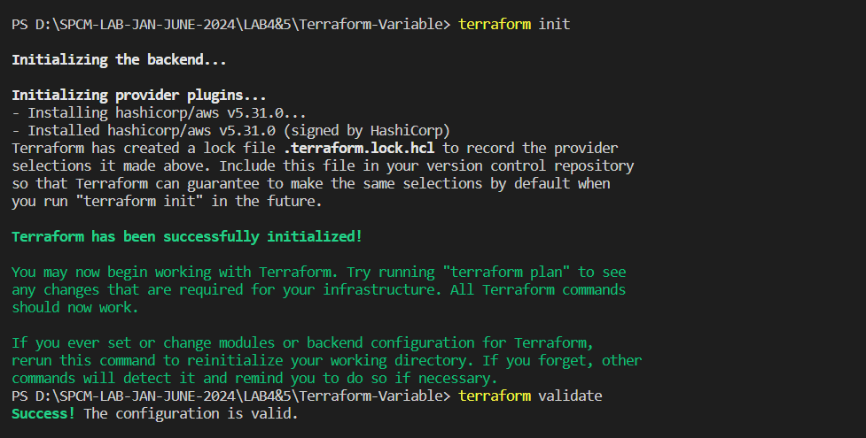

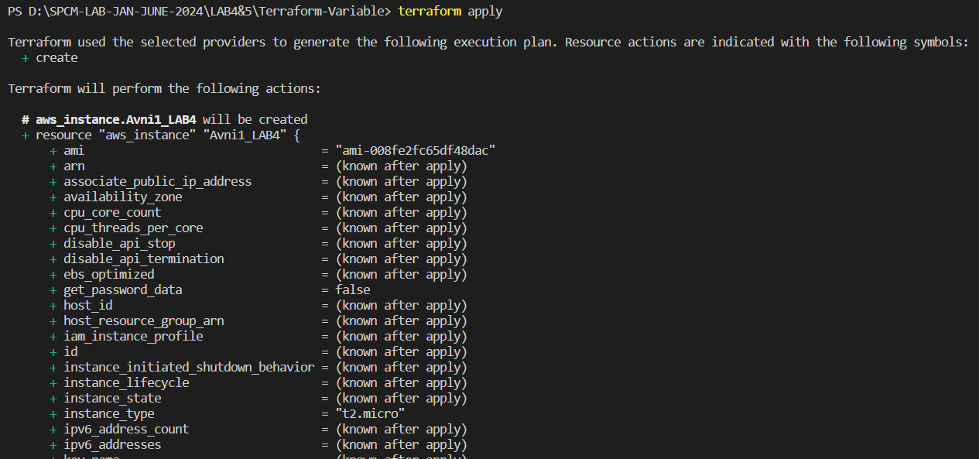

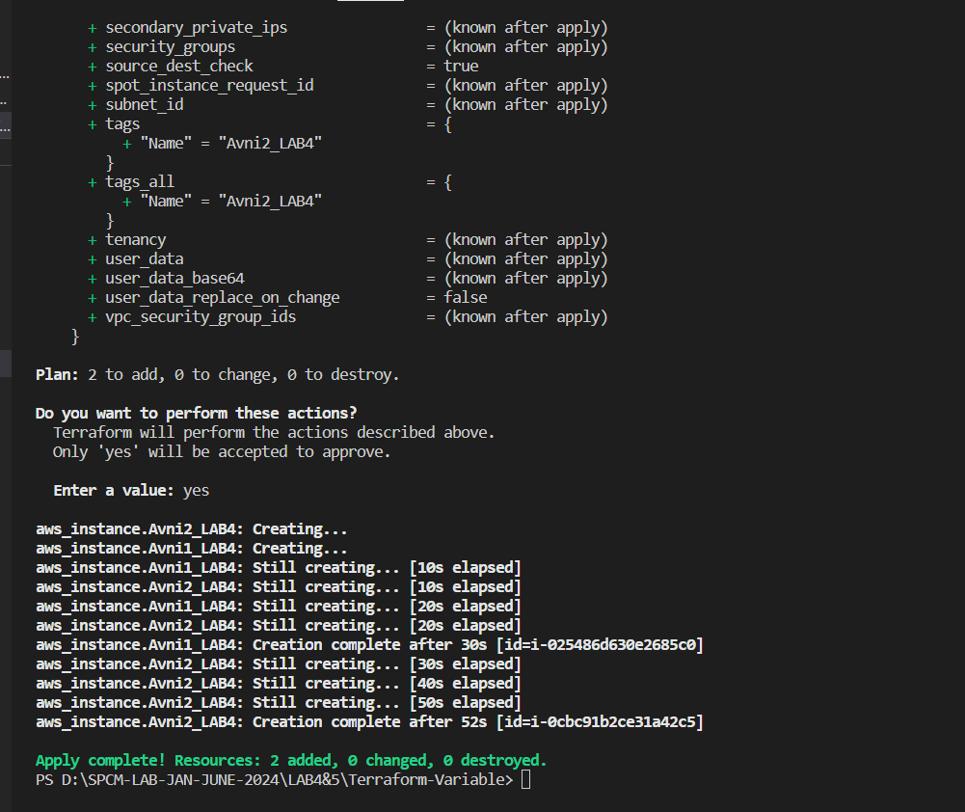

**terraform init terraform apply**

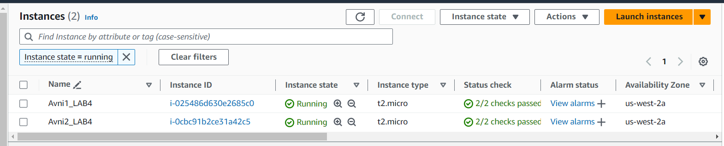Observe how the region changes based on the variable override.

1. **Clean Up:**

After testing, you can clean up resources.

**terraform destroy**

Confirm the destruction by typing yes.

